**MLCC Project – House Value Estimation**

**Performance Analysis**

**Linear Regression Model Accuracy:**

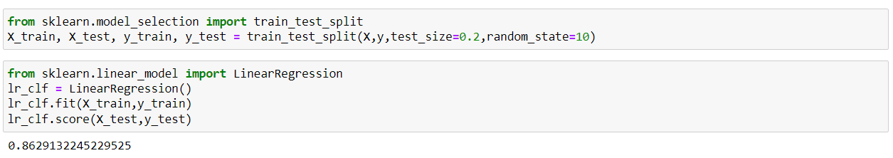

**K Folds Cross Validation:**

**5 Folds Validation – Accuracy Matrix:**

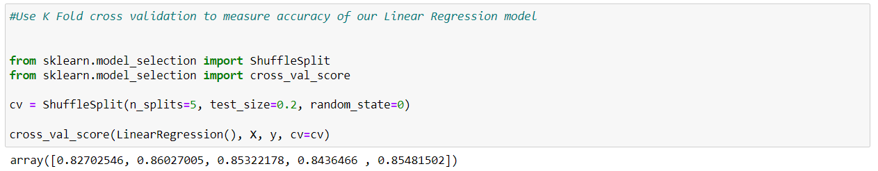

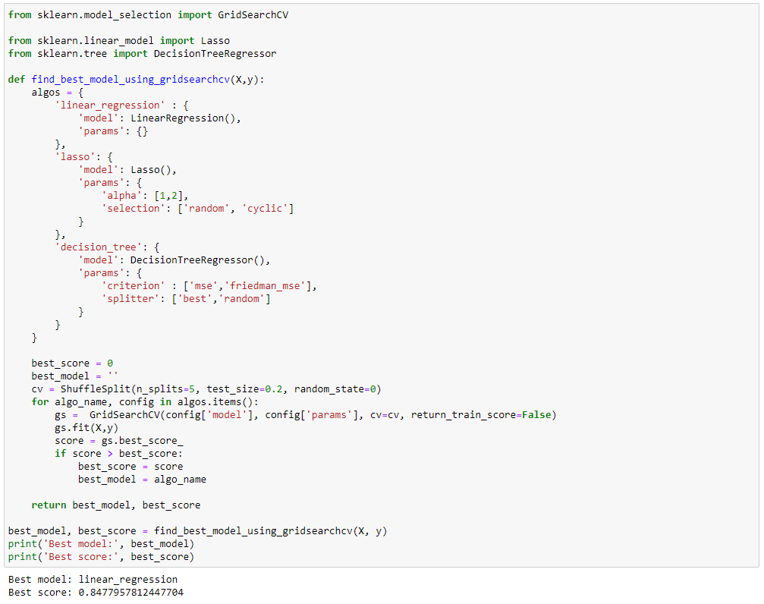

**Best Model – Linear Regression**

**Highest Accuracy – 84.77 %**